CS 305 Project One

Document Revision History

Version | Date | Author | Comments
1.0 | January 25, 2026 | Katie Baca Dempsey

Client



Developer
Katie Baca Dempsey

1. Interpreting Client Needs

Secure communication is extremely valuable to Artemis Financial. Artemis helps entrepreneurs, businesses, and government agencies manage financial plans including savings, retirement, investments, and insurance; security expectations are high dealing with such sensitive information. Additionally, Artemis’ software is utilized around the world. According to the UNCTAD 79% of countries in the world have data protection and privacy legislation which Artemis will need to comply with when operating in those countries. The federal trade commission Standards for Safeguarding Customer Information – the Safeguards Rule, for short – is to ensure that entities covered by the Rule maintain safeguards to protect the security of customer information, in the UK, data protection is governed by the UK General Data Protection Regulation (UK GDPR) and the Data Protection Act 2018, and in Japan, data protection is governed by the Act on the Protection of Personal Information (Act No. 57 of 2003; the “APPI”).

Artemis will need to safeguard client data as there are attackers who may try to access their customers’ information and investments both now and in the future. Currently, they may be at risk of SQL injection or unhandled errors exposing sensitive data. Because technology is continuously advancing, there is the potential for new exploits to develop over time as their product evolves, and as hackers develop new approaches to infiltrate secure systems.

Utilizing a resource such as the NIST Cybersecurity Framework would help Artemis adopt secure coding and business practices as well as maintain secure software moving into the future. Open-source libraries are valuable tools but need to be tested for vulnerabilities and utilized in a way that they are not leaving an open door to hackers. Once Artemis has ensured that their software is secure, it is vital to keep checking and running tests to catch new vulnerabilities as they surface.

2. Areas of Security

Because of the nature of Artemis Financials business, each area of the Vulnerability Assessment Process is an area to review.

Input Validation
All input should be untrusted and needs to be validated. Not performing input validation opens the application up to injection, which could put both information and functionality at risk. Input should be limited in length and the characters that can be utilized to reduce injection risks.

API
When utilizing an API, it is vital not to simply trust the work completed by another party. The API may have security flaws in itself or may not be secure when combined with other features. Researching the APIs used and running a dependency check to reveal vulnerabilities can help to address these flaws or result in a decision to move in another direction.

Cryptography
Artemis is both storing and communicating sensitive information belonging to customers. Keeping this data encoded in storage and as it sent and received helps to prevent exposure. Per OWASP, don’t come up with this algorithm yourself, for symmetric encryption, “AES with a key that's at least 128 bits (ideally 256 bits) and a secure mode should be used as the preferred algorithm.” Additionally, “In some cases there may be regulatory requirements that limit the algorithms that can be used, such as FIPS 140-2 or PCI DSS”.

Client/Server
Artemis Financials system is not operating in a vacuum. They will need to communicate information within their business but also to outside sources. It is extremely important that opening this transfer of information does not create any vulnerabilities.

Code Error
There is no error handling present in this code which could reveal sensitive information and lead to exposure of information or denial of service.

Code Quality
Best practices must be followed. A lack of index bounds checking opens the software up to denial-of-service attacks. Utilizing the NIST framework will help to button up issues such as this.

Encapsulation
Encapsulation is a best practice, but it may potentially secure a dependency vulnerability that does not currently have a fix otherwise.

3. Manual Review

Missing from the code base currently is input validation. Input validation will need to be added to safely receive inputs from users utilized in several cases. Input should be limited in length and the characters that can be used to prevent misuse.

Within DocData.java Artemis is making a connection to the database first, without validation of the user input to look up a document and risks exposing the username and password.

Within customer.java, the variable account_balance is not private and again, the user input is not validated.

4. Static Testing
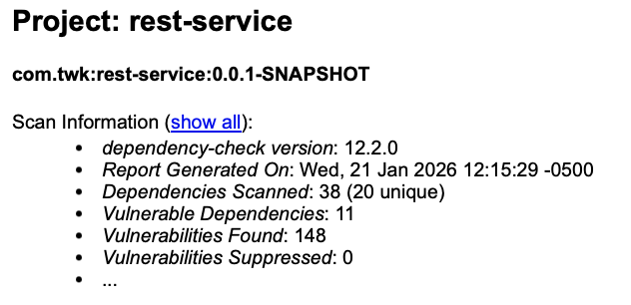
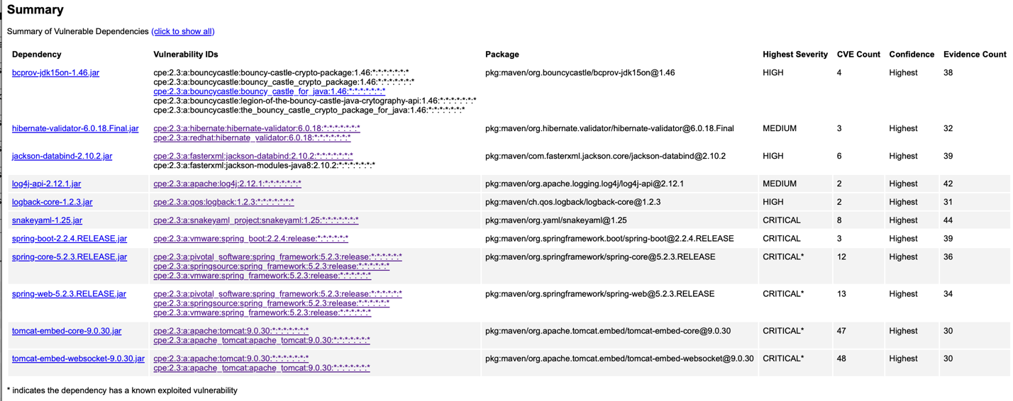
Dependency | Description
bcprov-jdk15on-1.46.jar | The Bouncy Castle Crypto package is a Java implementation of cryptographic algorithms. This jar contains JCE provider and lightweight API for the Bouncy Castle Cryptography APIs for JDK 1.5 to JDK 1.7.
hibernate-validator-6.0.18.Final.jar | Hibernate's Bean Validation (JSR-380) reference implementation.
jackson-databind-2.10.2.jar | General data-binding functionality for Jackson: works on core streaming API
log4j-api-2.12.1.jar | The Apache Log4j API
logback-core-1.2.3.jar | logback-core module
snakeyaml-1.25.jar | YAML 1.1 parser and emitter for Java
spring-boot-2.2.4.RELEASE.jar | Spring Boot
spring-core-5.2.3.RELEASE.jar | Spring Core
spring-web-5.2.3.RELEASE.jar | Spring Web
tomcat-embed-core-9.0.30.jar | Core Tomcat implementation
tomcat-embed-websocket-9.0.30.jar | Core Tomcat implementation

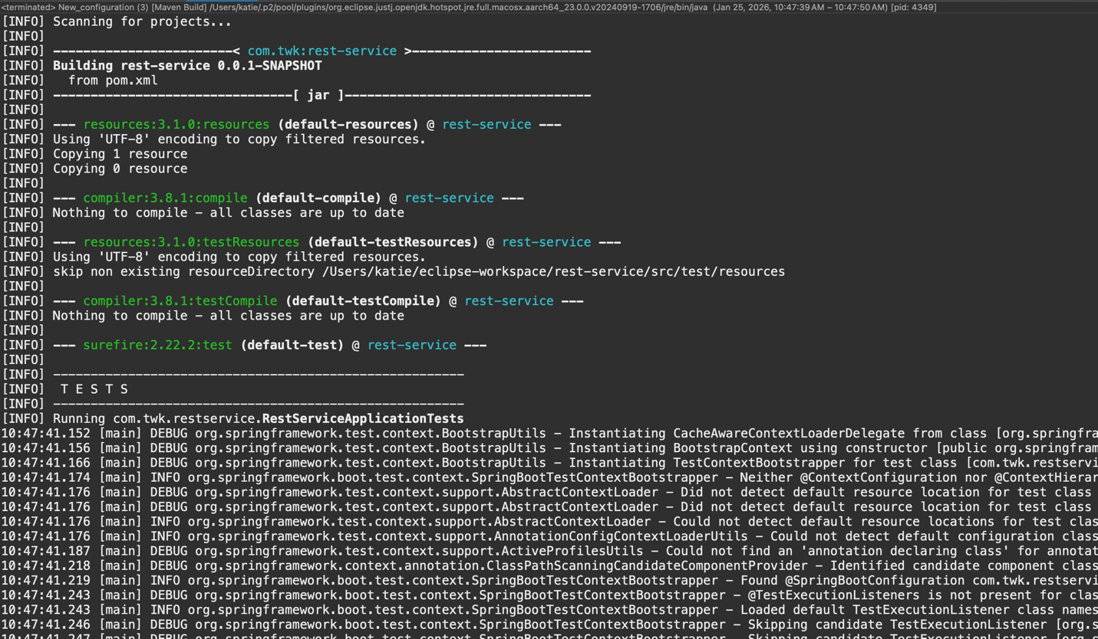
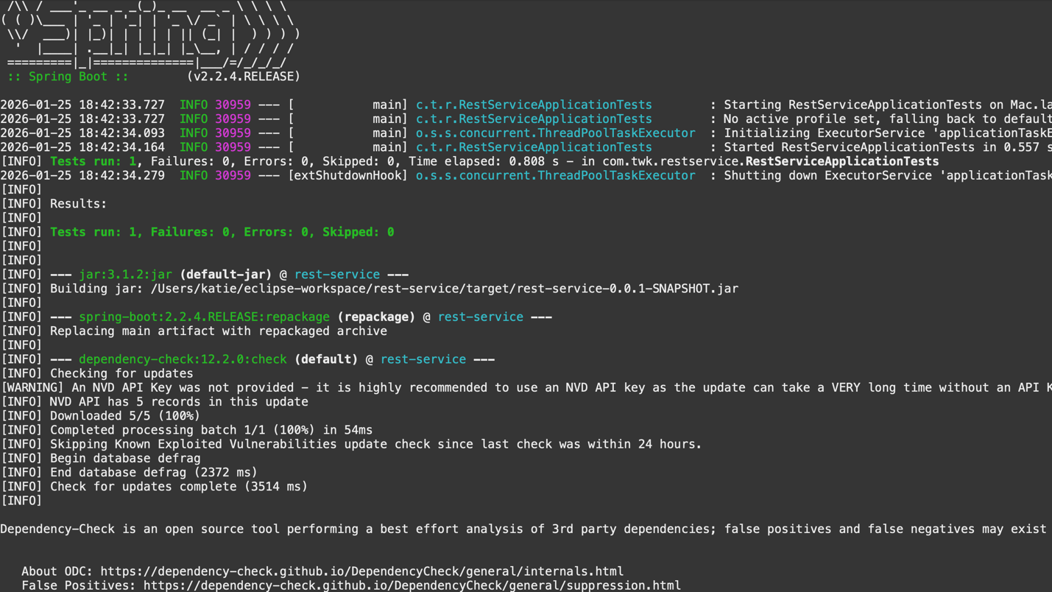
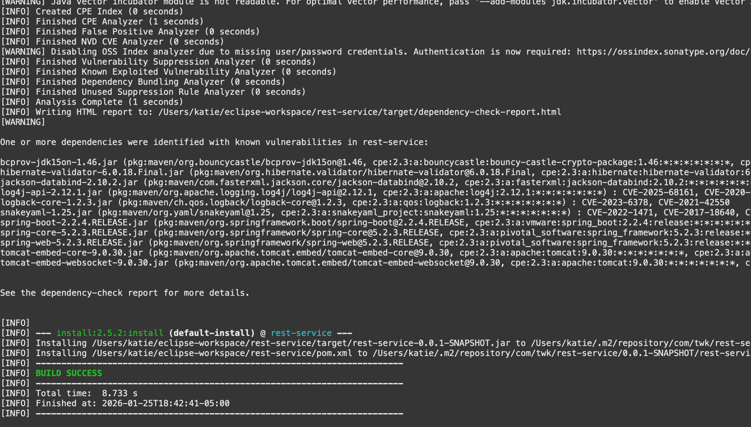

bcprov-jdk15on-1.46.jar
CVE-2016-1000338 – Upgrade to the newest version
CVE-2020-15522 – Upgrade to the newest version
CVE-2023-33202 – Upgrade to the newest version
CVE-2015-7940 – Upgrade to the newest version

hibernate-validator-6.0.18.Final.jar
CVE-2025-35036 – Patch available
CVE-2023-1932 - Supported versions of Satellite 6 embed vulnerable versions of hibernate-validator inside the candlepin component. However, the vulnerable SafeHtmlValidator functionality is not in use, so it is not possible to exploit it. (https://access.redhat.com/security/cve/cve-2023-1932)
CVE-2020-10693 – Patch available

jackson-databind-2.10.2.jar
CVE-2020-25649 – Patch available
CVE-2020-36518 – Update version
CVE-2021-46877 – Versions 2.12.6 and 2.13.1 include a fix
CVE-2022-42003 – Patch available, also resolved after version 2.13.4.1
CVE-2022-42004 – Upgrade version / vulnerable only with certain customized choices for deserialization
CVE-2023-35116 – Upgrade version

log4j-api-2.12.1.jar
CVE-2025-68161 – Patch available
CVE-2020-9488 - Fixed in Apache Log4j 2.12.3 and 2.13.1

logback-core-1.2.3.jar
CVE-2023-6378 – Upgrade version
CVE-2021-42550 – Upgrade version

snakeyaml-1.25.jar
CVE-2022-1471 – Upgrade version
CVE-2017-18640 – Upgrade version
CVE-2022-25857 – Upgrade version
CVE-2022-38749 – Upgrade version/Validate user input
CVE-2022-38751 – Upgrade version/Validate user input
CVE-2022-38752 – Upgrade version/Validate user input
CVE-2022-41854 – Upgrade version/Validate user input
CVE-2022-38750 – Upgrade version/Validate user input

spring-boot-2.2.4.RELEASE.jar
CVE-2023-20873 – Upgrade version
CVE-2022-27772 – Upgrade version
CVE-2023-20883 – Upgrade version

spring-core-5.2.3.RELEASE.jar
CVE-2022-22965 – Patch/Upgrade version
CVE-2024-22259 – Upgrade version
CVE-2021-22118 – Patch/Upgrade version
CVE-2020-5421 – Patch/Upgrade version
CVE-2022-22950 – Patch/Upgrade version
CVE-2023-20861 – Upgrade version
CVE-2023-20863 – Upgrade version
CVE-2022-22968 – Upgrade version
CVE-2022-22970 – Upgrade version
CVE-2021-22060 – Upgrade version
CVE-2021-22096 – Upgrade version

spring-web-5.2.3.RELEASE.jar
CVE-2016-1000027 – Upgrade version/Validate user input
CVE-2022-22965 – Patch/Upgrade version
CVE-2024-22259 – Upgrade version
CVE-2021-22118 – Upgrade version
CVE-2020-5421 – Upgrade version
CVE-2022-22950 – Upgrade version
CVE-2022-22971 – Upgrade version
CVE-2023-20861 – Upgrade version
CVE-2023-20863 – Upgrade version
CVE-2022-22968 – Upgrade version
CVE-2022-22970 – Upgrade version
CVE-2021-22060 – Upgrade version
CVE-2021-22096 – Upgrade version

5. Mitigation Plan

After utilizing the NVD and reviewing the specific information provided about each vulnerability, there are an array of ways to address these different dependencies. Some vulnerabilities have already been resolved, or there may be a patch or version upgrade available. In a few instances, it was noted that user input was related to the vulnerability, and that validation and or restricting input size and characters would prevent abuse. In other cases, it is noted that there are settings that should be adjusted to invalidate the vulnerability or adjustments to how code is written, different approaches such as one constructor or variable type over another being utilized. Some feature combinations have created vulnerabilities and thus should not be utilized together. While some vulnerability issues have already been resolved, if there is not a fix available, it may be best to avoid using libraries with numerous vulnerabilities if possible.

The best way to protect Artemis and their users from external threats would be to follow the guidelines defined by OWAPS Secure Coding Practices. The following are two excerpts from the OWASP Cheat Sheet regarding securing private information.

Strong Cryptography

Any online platform that handles user identities, private information or communications must be secured with the use of strong cryptography. User communications must be encrypted in transit and storage. User secrets such as passwords must also be protected using strong, collision-resistant hashing algorithms with increasing work factors, in order to greatly mitigate the risks of exposed credentials as well as proper integrity control.

To protect data in transit, developers must use and adhere to TLS/SSL best practices such as verified certificates, adequately protected private keys, usage of strong ciphers only, informative and clear warnings to users, as well as sufficient key lengths. Private data must be encrypted in storage using keys with sufficient lengths and under strict access conditions, both technical and procedural. User credentials must be hashed regardless of whether or not they are encrypted in storage.

OWASP Secure Coding Practices-Quick Reference Guide
Communication Security:
[143] Implement encryption for the transmission of all sensitive information. This should include TLS
for protecting the connection and may be supplemented by discrete encryption of sensitive files or
non-HTTP based connections
[144] TLS certificates should be valid and have the correct domain name, not be expired, and be
installed with intermediate certificates when required
[145] Failed TLS connections should not fall back to an insecure connection
[146] Utilize TLS connections for all content requiring authenticated access and for all other sensitive
information
[147] Utilize TLS for connections to external systems that involve sensitive information or functions
[148] Utilize a single standard TLS implementation that is configured appropriately
[149] Specify character encodings for all connections
[150] Filter parameters containing sensitive information from the HTTP referrer, when linking to
external sites

OWASP secure coding practices-quick reference guide. OWASP Secure Coding Practices-Quick Reference Guide | OWASP Foundation. (n.d.). https://owasp.org/www-project-secure-coding-practices-quick-reference-guide/
User Privacy Protection Cheat sheet. User Privacy Protection - OWASP Cheat Sheet Series. (n.d.-b). https://cheatsheetseries.owasp.org/cheatsheets/User_Privacy_Protection_Cheat_Sheet.html
Nguyen, S. T. (2024, December 23). FTC Safeguards Rule: What your business needs to know. Federal Trade Commission. https://www.ftc.gov/business-guidance/resources/ftc-safeguards-rule-what-your-business-needs-know#whoscovered
GOV.UK (2025, January 22). Data protection. GOV.UK. https://www.gov.uk/data-protection
Data Protection and Privacy Legislation Worldwide. UN Trade and Development (UNCTAD). (n.d.). https://unctad.org/page/data-protection-and-privacy-legislation-worldwide
National Institute of Standards and Technology. NIST. (2026, January 25). https://www.nist.gov/

